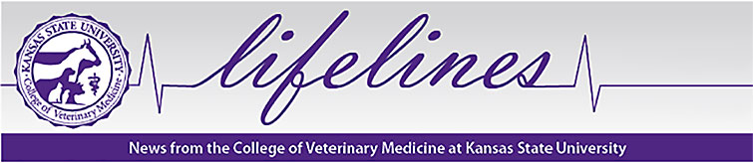

January 2018

Kansas as State University distinguished alumnus – Gene Lyons - world-renowned equine parasitologist honored

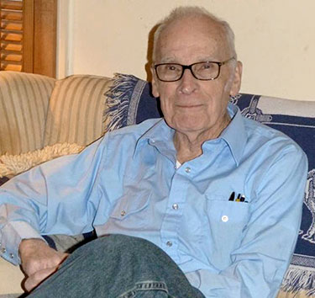
Professor Gene Lyons, equine parasitologist, who has a master's degree he earned in 1958 (Kansas State University) and a Ph.D. in 1963 (Colorado State University)
Professor Gene Lyons (M.S. 1958), a distinguished alumnus of Kansas State University and a world-renowned equine parasitologist will be honored January 19th at a Memorial Reception at the University of Kentucky where he engaged in veterinary parasitology research for 56 years. Lyons had an active parasitology research agenda until his death, Dec. 7, 2017 at age 86.
Dr. James A. Guikema, Associate Director of K-State’s Division of Biology in his tribute to Dr. Lyons said: “To devote 56 years of a life to science is a reality to be embraced. Professor Lyons career has captured the motto which the Division of Biology has placed on their 50th anniversary commemorative coin (1967-2017): ‘Yesterday’s Success, Tomorrow’s Innovation’. He embodies both the success and the innovation that the Division of Biology was seeking.” The 56 commemorative coins, “one coin for each year of exceptional scientific service by Professor Gene Lyons” will be handed out at the Memorial Reception at University of Kentucky.
Lyons was a protégé of Dr. Merle Hansen who had an excellent cadre of graduate students at K-State, many of whom went on to distinguish themselves in parasitology careers. After obtaining his doctorate in parasitology at Colorado State University, Dr. Lyons began his 56 year career at the Gluck Equine Research Center University of Kentucky where he continued his work to the morning he died while on his rounds of the horse farm.
Dr. Guikema in his tribute for the Memorial Reception stated: “The United States has an excellent program in combating parasites – stemming in part from Professor Lyons’ work. With his example, we at K-State seek to understand and stop the effects that pathogens, bacteria and virus have in limiting our lives. This is something that Gene helped establish in his time as a valued graduate student at K-State. A major federal facility is now relocating to Manhattan, Kansas based on this ongoing program. It represents a major transition of a federal facility from Plum Island to Kansas.”
David Horohov, Gluck Center director and department chair at University of Kentucky said: "Dr. Lyons made multiple contributions to the field of parasitology through a lifetime of devotion to his work and a commitment to excellence to this field. His legacy will include the contributions he has made and the people he has trained.”
Martin Nielsen, associate professor and Schlaikjer Professor of Equine Infectious Disease at the Gluck Center wrote in his tribute: “Dr. Lyons was a legend, a giant in veterinary parasitology. His list of contributions to veterinary science is remarkable… People traveled from across the world to meet him and to learn from him.” (in the scientific journal Veterinary Parasitology)
Lyons published more than 300 peer-reviewed articles and book chapters. He mentored more than a dozen graduate and undergraduate students and hosted and mentored more than 25 visiting scientists and students in his laboratory throughout his career.
Dr. Lyons with his research colleague, Dr. Harold Drudge established two equine parasitology research herds at the University of Kentucky in the 1970s. These historic horse herds are now named the Gene Lyons Historic Parasitology Herds. The herds are unique in the world today and remain an invaluable resource for the parasitology research program today. One herd is harboring multi-drug resistant parasites and the other has been kept without deworming since 1979.
Born May 6, 1931 in Yankton, South Dakota, Gene Lyons served in the United States Coast Guard from 1950-1953. He received his bachelor’s degree in zoology (wildlife) from South Dakota State University in 1956, his master’s in zoology (parasitology) from Kansas State University in 1958 and his doctorate in zoology (parasitology) from Colorado State University in 1963. He is buried in the Lyons family plot in Yankton, South Dakota.

